BIS 305

Assignment 7

Due 11/7/22

11. The Excel file National Football League provides various data on professional football for one season.
a. Construct a scatter diagram for points/game and yards/game in the Excel file. Does there appear to be a linear relationship?

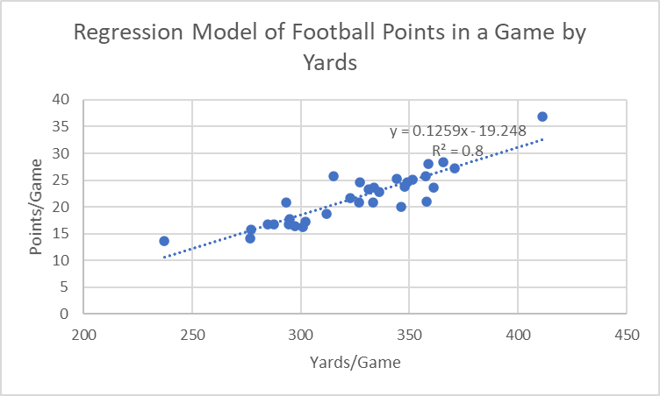

There appears to be a positive linear relationship between yards ran and points scored. The more Yards, the more points scored

b. Use the Regression tool to develop a model for predicting points/game as a function of yards/game. Explain the statistical significance of the model and the R2 value.

Using the information highlighted, I can understand that the regression equation is
y= -19.099 + .125x. For everyone extra yard ran, we can expect the overall score of a game to increase by .125

The

SUMMARY OUTPUT
Regression Statistics
Multiple R | 0.893509319
R Square | 0.798358903
Adjusted R Square | 0.791405762
Standard Error | 2.298671233
Observations | 31

ANOVA
 | df | SS | MS | F | Significance F
Regression | 1 | 606.6955934 | 606.6955934 | 114.819888 | 1.34531E-11
Residual | 29 | 153.2327937 | 5.283889438
Total | 30 | 759.9283871
.

 | Coefficients | Standard Error | t Stat | P-value | Lower 95% | Upper 95% | Lower 95.0% | Upper 95.0%
Intercept | -19.09923409 | 3.818775109 | -5.001403212 | 2.52676E-05 | -26.90950614 | -11.28896205 | -26.90950614 | -11.28896205
344.1 | 0.125319367 | 0.011695253 | 10.71540424 | 1.34531E-11 | 0.101399888 | 0.149238846 | 0.101399888 | 0.149238846

RESIDUAL OUTPUT
Observation | Predicted 25.2 | Residuals
1 | 18.62189533 | -2.421895335
2 | 18.7472147 | -1.547214702
3 | 15.62676247 | 0.173237533
4 | 16.60425353 | 0.095746472
5 | 17.64440427 | 3.255595727
6 | 24.51190558 | -0.711905578
7 | 24.92545949 | 0.174540511
8 | 26.73005837 | 1.669941628
9 | 24.29886265 | -4.298862654
10 | 21.36638947 | 0.23361053
11 | 27.35665521 | -0.156655206
12 | 22.7073067 | 0.992693305
13 | 25.8528228 | 2.247177196
14 | 25.68990763 | 0.010092373
15 | 15.58916666 | -1.489166657
16 | 16.93008388 | -0.230083882
17 | 23.03313705 | -0.233137049
18 | 32.43208956 | 4.367910435
19 | 26.16612122 | -2.466121221
20 | 22.43160409 | 0.868395912
21 | 17.83238332 | -1.032383324
22 | 17.84491526 | -0.14491526
23 | 25.77763118 | -4.777631184
24 | 21.93032662 | 2.66967338
25 | 20.40143034 | 5.398569655
26 | 10.63905166 | 3.060948335
27 | 24.62469301 | -0.024693008
28 | 18.18327755 | -1.783277551
29 | 21.855135 | -0.955135
30 | 19.96281256 | -1.162812561
31 | 22.68224282 | -1.782242822

17. Use the results for Problem 11 (National Football League) to analyze the residuals to determine if the assumptions underlying the regression analysis are valid. In addition, use the standard residuals to determine if any possible outliers exist.
The residual plot below has a constant variance (No pattern), is approximately normally distributed (with a mean of zero), an is independent of one another. This validates the regression analysis.
I added a residual plot of our data down below. I then added a table that highlights residuals bigger than 3 or less than -3. These residuals are considered outliers.
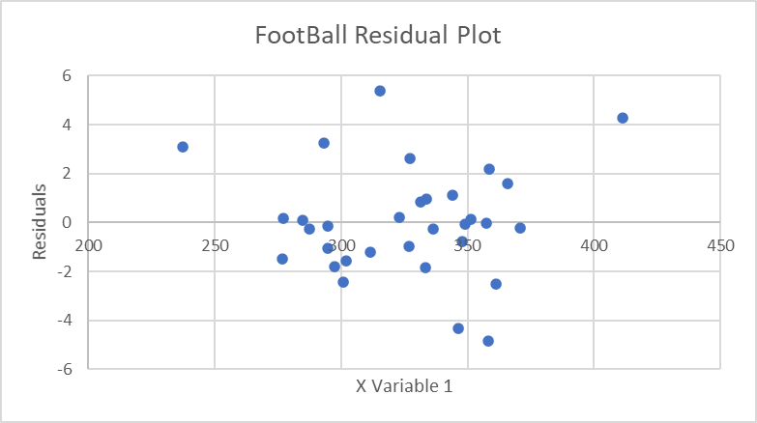

Residuals
1.12930582
-2.444872576
-1.570761708
0.163877688
0.081942455
3.237062657
-0.761661797
0.122904067
1.610100561
-4.347650272
0.198155426
-0.219345101
0.951141709
2.191324487
-0.045019641
-1.498355572
-0.245369289
-0.276170035
4.282145038
-2.523398344
0.828097801
-1.051771042
-0.164359955
-4.833142033
2.63165433
5.367501745
3.074265156
-0.074962016
-1.804260612
-0.992812191
-1.191886292
-1.823680464

24. Using the data in the Excel file Home Market Value, find the best multiple linear regression model for estimating the market value as a function of both the age and size of the house. Predict the value of a house that is 30 years old and has 1,800 square feet, and one that is 5 years old and has 2,800 square feet.

36. For the Excel file Auto Survey:
a. Find the best regression model to predict miles/gallon as a function of vehicle age and mileage.
b. Using your result from part a, add the categorical variable purchased to the model. Does this
change your result?
c. Determine whether any significant interaction exists between vehicle age and purchased variables.

